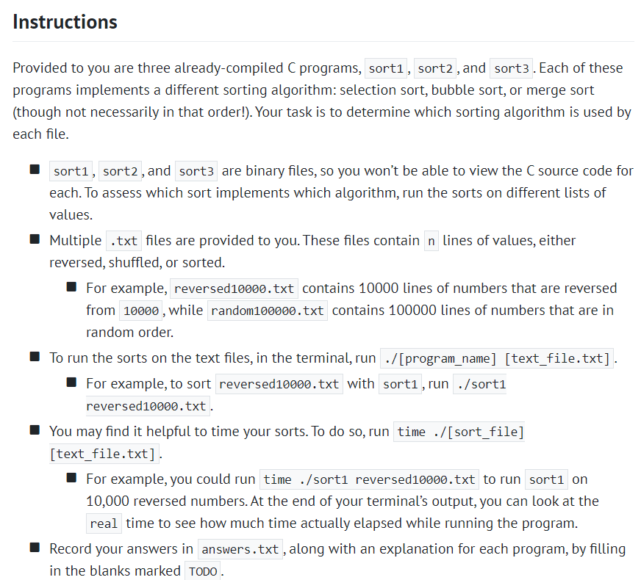

My solution:

1. figure out the files in lab3



1. record each running time of **random50000.txt**
2. sort1(random50000.txt)

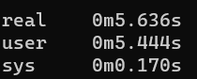

1. sort2(random50000.txt)

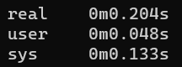

1. sort3 random50000.txt

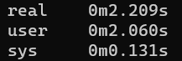

**The fastest way to search for random.txt merge sort, so sort2 is the merge sort**

1. record each running time of **sorted50000.txt**
2. sort1

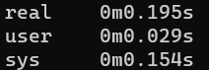

1. sort2

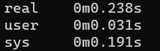

1. sort3

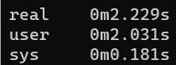

**The fastest way to search for sorted.txt is the bubble sort,but sort2 and sort1’s data is so similar,so let’s try reversted.txt**

1. record each running time of **reversed.txt**
2. sort1

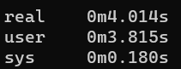

1. sort2

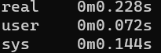

1. sort3

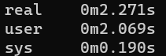

**It seems that this set of data is unfriendly to Buble Sort, which once again loses out to Selection Sort**